#"k" is concidered as the time slots for the Mapper and Reducer Max value update
k = {0, 40, 80, 120, 160, 200, 240}

#delta k is the different in the time frames between two readings

delta k = 40

#u(k) considered as percentage of job completed by Mapper divided by 10
uWave(k) = {0.8, 2.2, 4.2, 6.5, 8.7, 10.0}

#p(k) considerd as Job Execution Rate from the values

pWave(k) = (uWave(k)/(delta k) )*6

pWave(k) = {0.1200, 0.3300, 0.6300, 0.9750, 1.3050, 1.5000}

#Linear Function: p(k+1) = a*p(k) + b*u(k)

Mean input and output:
uDash = .54
pDash = .81

Values of Si Estimates for the Data
S = {1.0112, 2.1443, 11.2305, 0.8111, 2.5900}

Parameter a and b calculation:

a = (S(3)*S(4)-S(2)*S(5))/(S(1)*S(3)-(S(2))^2);
b = (S(1)*S(5)-S(2)*S(4))/(S(1)*S(3)-(S(2))^2);

a = 0.5261

b = 0.1302

pHat =
-0.4229 -0.2942 -0.1103 0.1011 0.6900

Final Data Table:

k | uWave(k) | pWave(k) | u(k) | p(k)
40 | .08 | .12 | -0.46 | -0.69
80 | 2.2 | .33 | -0.32 | -0.48
120 | 4.2 | .63 | -0.12 | -0.18
160 | 6.5 | .975 | 0.11 | 0.165
200 | 8.7 | 1.305 | 3.3 | 0.495
240 | 10.0 | 1.5 | 4.6 | 0.69

Final Graph:

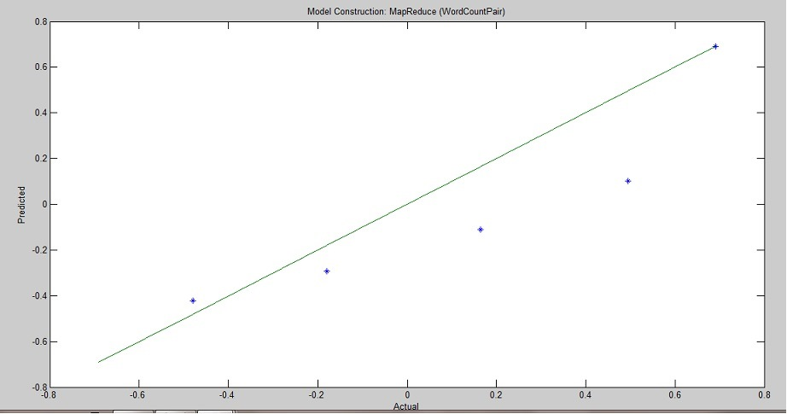

RMSE, R^2, Correlation Coefficient:

- RMSE:
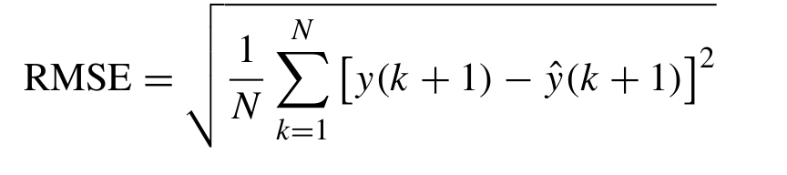

= { [ (-0.0571)² + (0.1142)² + (0.0547)² +(0.3939)² + (0)² ] /5 }^{1/2}

= { [ 0.1745 ] /5 }^{1/2}
={ 0.0349 }^{1/2}

= 0.1868

- R²:
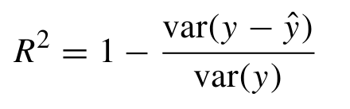

= 1 – (0.036839)/(0.29745)
=1 – 0.123849386
=0.876150614

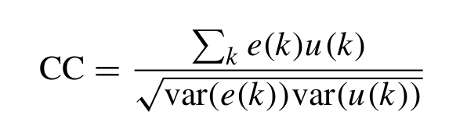
- Correlation Coefficient

= (0.018272-0.013704+0.006017+1.29987+0) / ( 0.036839 * 5.1795 ) ^{½}

= (1.3106) / (0.1906) ½

= (1.3106 / 0.4366 )

= 3.0018

